|  |
| --- |
| **YEAR 12 Essentials Mathematics**  **Semester 2 2020**  **Test 4 – Probability, Longitude/Latitude & Time Zones** |
| Mark: ______ /40 marks  Name: ______________________ Total Time: 45 minutes |

***Full working out must be shown to get full marks.***

***Attempt all questions***

***Resources allowed:***

***1 A4 page, (1 side) of hand written notes, ruler, calculator***

1. Use the map of the world to answer the following questions: (6 marks)

**B**

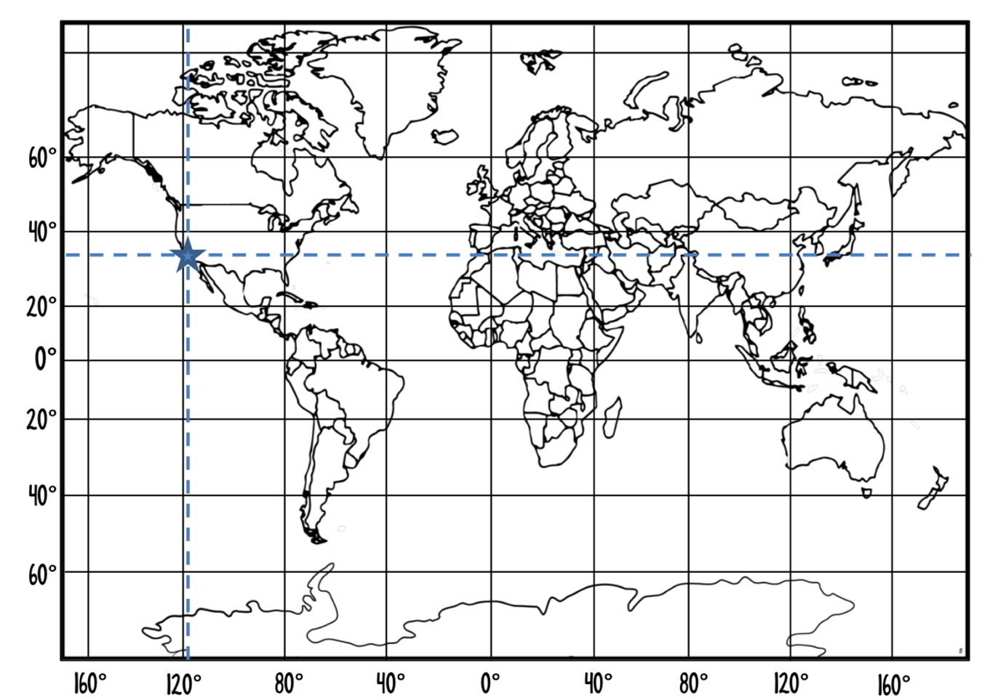

**A**

1. Name the significant line labeled A.__________________________________
2. Name the significant line labeled B.________________________________
3. Los Angeles is located on the map with a triangle. What are the coordinates of Los Angeles? ____________________________________________
4. South Africa is located on the map with a circle. What are the approximate coordinates of South Africa? ____________________________________________
5. Calculate the arc length (shown in bold) in the following circles (Answer in cm) (5 marks)
6. (b)

|  |  |
| --- | --- |
|  |  |

1. Find the **arc angle** between Bali (5°S, 115°E) and Mandurah (35°S, 115°E) correct to the nearest degree. (2 Mark)
2. *A* (23°N, 121°W) and *B* (65°N, 121°W) are two points on the surface of the Earth. Find the distance to the nearest kilometer between the points *A* and *B.*

(Approximate the radius of the Earth as 6 400km) (3 Marks)

1. Find the distance between Stockholm (59°N 18° E) and Cape Town (34°S 18°E) correct to the nearest kilometer.

(Approximate the radius of the Earth as 6 400 km) (3 Marks)

1. Using the Time Zones table below answer the following questions (4 Marks)

|  |  |
| --- | --- |
| **City** | **Time** |
| Sydney | GMT+10 |
| Melbourne | GMT+10 |
| Adelaide | GMT+9:30 |
| Perth | GMT+8 |
| Darwin | GMT+9:30 |
| Brisbane | GMT+10 |
| Hobart | GMT+10 |

* 1. If it is 3: 51 PM in Sydney, what time would it be in Darwin?

* 1. If it is 11:45 pm in Perth, what time would it be in Melbourne?

1. If the time in Bangkok (GMT + 7) is 4:30am what time is it in Beirut (GMT +3)? (2 mark)

1. Han, who is in Canberra (GMT +10) at the moment, has an interview over Skype with the human resources manager of an American trading firm scheduled for 3 pm on Monday, New York (GMT -5) time. (3 Marks)
2. Calculate the time difference between the two cities.
3. Hence find the time in Canberra when it is 3pm on Monday in New York.
4. What day will the interview fall on in Canberra?
5. A builder offers three roof colours, and three interior wall colours. The roofs can be Red (R), Mauve (M) or Cyan (C), and the interior walls can be Navy(N), Yellow(Y) or Pink(P). (6 marks)
6. Show all the colour combinations available.
7. What is the chance someone will get a Mauve roof with yellow walls?
8. What is the probability they will pick Navy wall, if they have already chosen a Red roof?
9. In a car race there are 48 Holden cars and 16 Ford cars, with every car having an equal chance of winning. Knowing this Jarod said that Holden and Ford are equally likely to win, Jess said that Holden is twice as likely to win than Ford and Jimbo said that Holden is three times more likely to win over Ford.   
   Who is correct and why? (3 marks)
10. In a set of four numbered cards, two cards are picked at random and the sum of the two cards is listed below. (3 marks)

{15, 10, 8, 11, 9, 4}

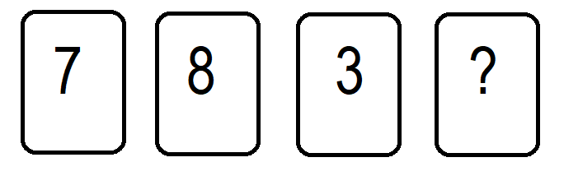

1. What is the value of the fourth card?
2. If two cards are picked at random, what is the probability that the sum of their numbers is even?
3. If two cards are picked at random, what is the probability that the sum of their numbers is at least 10?

END OF TEST